- The next two exercises are based on the following information from L. Devroye, L. Gyorfi, and G. Lugosi. A Probabilistic Theory of Pattern Recognition. Springer, 1996.
Let (X, Y) be a pair of random variables taking their respective values from R^{d} and {0, 1}. The random pair (X, Y) may be described by the pair (μ, η), where μ is the probability measure for X and η is the regression of Y on X:

Thus, η(x) is the conditional probability that Y is 1 given X = x.

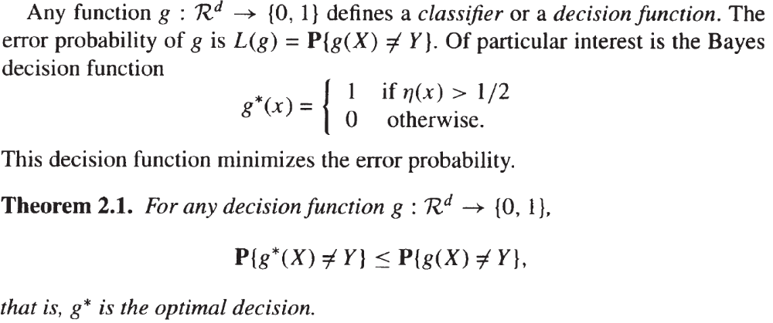

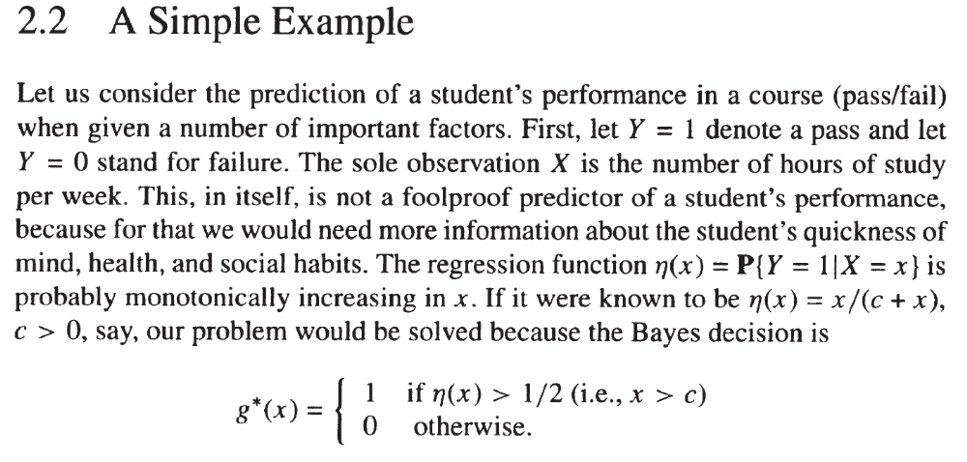
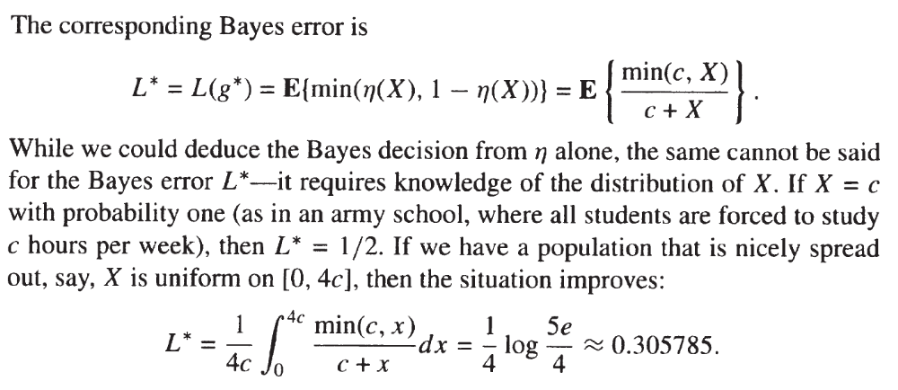

- Write the Julia code that computes the value of L* (given the above formula) when X = c with probability one and when X is a random variable uniform on [0, 4c ]. How the results compare with the theoretical ones presented above?
- Write the Julia code that computes the value of L* based only on the definition of g*(x) (given above) and the definition of L* (L* = L(g*) = P(g*(x) ≠ Y)). How the results compare with the theoretical ones and the results obtained at a)?

- Modify the code changepoint code from Lecture 2 to contain 2 switchpoints instead of 1.

